**Q1 = What is software? What is software engineering ?**

**ANS =** Software is a set of instructions or programs that tell a computer what to do.

It's a collection of data, instructions, and algorithms that operate computers,

manage data, and perform specific tasks.

Software engineering is the application of engineering principles and techniques

to design, develop, test, and maintain software systems. It's a disciplined

approach to creating reliable, efficient, and maintainable software that meets

user requirements.

**Q2 = Explain types of software.**

**ANS =** Types of software.

A) Application= the most common. Soft ware application Hoste Software is a Computer Software package that performs a specific function for a user, or in same Cases, for another app

Ex paint, power point, etc

B) System= these software programs are designed to rum a computer's application program and hardware

Ex Notepad, Calculator etc

C) Driver =Also known as device. drivers, this Software is often Considered a of system software. type

Eg video driver, Audio-11- etc

D) Middle= ware the term middleware describes software that mediates between app and System Software or between two different kinds of app soft ware

Eg database middle ware, app Server Midea

E) Programming= Computer programmers. use programming system software to Users site Code programming Enable develop programming develop, write test, and program. debug other software

Ego Turbo, Eclipse etc.

**Q3=What is SDLC? Explain each phase of SDLC.**

**ANS= SDLC (Software Development Life Cycle)** is a process used to develop software. It's a framework that outlines the stages involved in developing software, from planning to maintenance. SDLC is a structured approach to developing software that ensures high-quality software is delivered on time, within budget, and meets user expectations.

**Phases of SDLC**

1. **Planning**: Define project goals, timelines, and resources. Identify the problem, opportunities, and objectives.
2. **Requirements Gathering**: Collect information about software needs from stakeholders, customers, and users. Define the functional and non-functional requirements.
3. **Design**: Create a detailed blueprint for the software, including architecture, components, and interfaces.
4. **Implementation**: Write the code, develop the software, and integrate the components.
5. **Testing**: Check for errors, bugs, and defects. Ensure the software meets the requirements and works as expected.
6. **Maintenance**: Fix bugs, update the software, and improve its performance. Provide ongoing support and maintenance to ensure the software continues to meet user needs.

**Q4 = What is DFD? Create a DFD diagram on Flipkart.**

**ANS=** **DFD (Data Flow Diagram)** is a graphical representation of the flow of data through a system. It's a tool used to model and analyse the data processing and transformation within a system. DFDs are used to visualize the data flow, identify data sources and destinations, and define the processes that transform the data.

**Entities:**

* Customer
* Database

**Processes:**

* Search Products
* Add to Cart
* Checkout

**Data Flows:**

* Customer → Search Products → Product List
* Customer → Add to Cart → Cart Contents
* Customer → Checkout → Order Details
* Database → Search Products → Product Information
* Database → Add to Cart → Cart Update
* Database → Checkout → Order Confirmation

**Data Stores:**

* Product Database

This simplified DFD diagram shows the main data flows and processes involved in a customer's interaction with Flipkart. The customer searches for products, adds them to the cart, and checks out, with the database providing product information and updating the cart and order status.

**Q5 = What is Flow chart? Create a flowchart to make addition of two numbers.**

ANS= A **Flowchart** is a graphical representation of a sequence of steps or processes that describe a workflow, algorithm, or system. It's a visual tool used to illustrate the flow of control, data, or materials through a process or system.

* flowchart of make addition of two numbers
* 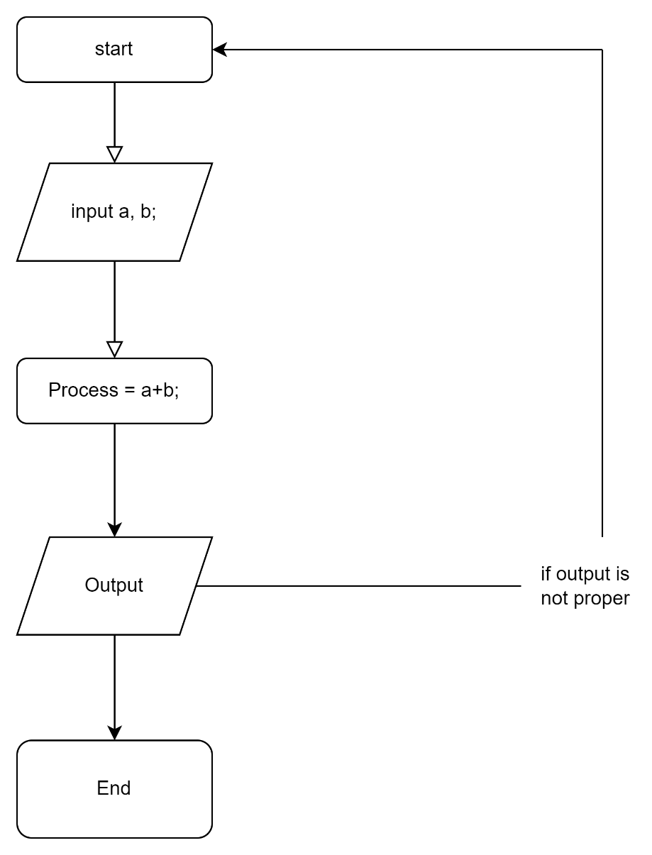

**Q6 = What is Use case Diagram? Create a use-case on bill payment on paytm.**

**ANS=** A **Use Case Diagram** is a graphical representation of the interactions between a system and its users, also known as actors. It's a high-level visualization of the system's functional requirements, showing how the system responds to user interactions.

